Extreme Heat Communications Plan Template

DIRECTIONS:
This is a template for an Extreme Heat Communication Plan to be used during an extreme heat event. To tailor this template for use by your community, replace the content between the < and > symbols.
Tailor this communications plan template to articulate the communication strategies you will use to communicate with both tribal community members and between Tribal emergency services, support departments and critical tribal organizations involved in the extreme heat response.
Your plan should identify communication strategies you will use for communicating heat-related information before, during and after an extreme heat event. Develop this communication plan before the heat event and update your plan after an extreme heat event using lessons learned from implementing your plan.
There should be frequent (i.e. daily) communication between the Tribal Office of Emergency Services/Incident Command Structure or other entity who is in charge of the Tribe’s response to a heat event and the tribal support departments and critical tribal organizations such as Daycare Centers, Schools, Elder Organizations, etc.
Public Health and Safety Messages used with community members and tribal programs should include information on what to do (e.g., how to prevent symptoms of heat-related illnesses), characteristics of persons more vulnerable to extreme heat and where to go for more information.
Your plan should specifically outline how Public Health and Safety Messages will be transmitted throughout the Tribe using outlets such as television, radio, internet, and distribution of fliers and posters.
Message Templates included in your communication plan should be tailored to tribal demographics and target vulnerable groups in the tribal community. For example, an Extreme Heat tip and fact sheet should be translated into the top 2-3 languages spoken in community and use language that is readily understood by all ages and education levels.

I. Designated Media Outlets
Below is a list of the media outlets that will be utilized during an extreme heat emergency to communicate public health and safety information.
Media Outlet Name | Point of Contact | Phone | Email
<local newspaper> | <name> | <999-999-9999> | <email@email.com>
<local radio station> | <name> | <999-999-9999> | <email@email.com>
<local TV station> | <name> | <999-999-9999> | <email@email.com>
<Tribe’s social media> | <name> | <999-999-9999> | <email@email.com>

II. PHASE I: SEASONAL READINESS

Communication Strategy Before an Extreme Heat Event
- <Insert the strategies you will use for communication between tribal emergency services/incident command structure, support departments (e.g. transportation, Tribal OSHA, Tribal EPA, Social Services, Community Health Department) and critical tribal organizations (e.g. churches, daycare, Head Start, School, Community Centers, Senior Centers, skilled nursing facilities, assisted living facilities, clinics, EMS, dialysis centers) participating in the response to the heat event (extreme heat response plan).>
- <Insert communication strategies you will use in the Spring with tribal members and vulnerable community members to prepare them for extreme heat events. Include a description of how information will be distributed regarding the availability of resources such as LIHEAP funding for cooling assistance, home weatherization, electric bill funding assistance for low income tribal members, transportation to cooling centers, and the availability of motel vouchers, bottled water, box fans and/or A/C units for distribution to vulnerable groups by the Tribe, etc.>

III. PHASE II & III: HEAT WATCH & HEAT WARNING

Communication Strategy During an Extreme Heat Event:
- Insert the communication methods that will be used between tribal emergency services/incident command structure, support departments (e.g. transportation, Tribal OSHA, Tribal EPA, Social Services, Community Health Department) and critical tribal organizations (e.g. churches, daycare, Head Start, School, Community Centers, Senior Centers, skilled nursing facilities, assisted living facilities, clinics, EMS, dialysis centers) participating in the response to a heat event (heat response plan) to ensure that strategies are being coordinated and implemented smoothly.
- Insert communication strategies for using tribal media outlets to inform tribal members of ways to identify and prevent heat-related illnesses, cooling centers/places, etc.
- Insert communication strategies that will be used to specifically target high risk groups.
Below is a table listing the individuals/organizations to be contacted in the event of a heat emergency.
Entities | Contact Information | MEANS OF COMMUNICATION
Agricultural Community/Farmers | <name>  <phone number>  <email address> | <ID means of communication>
School District/Educators | <name>  <phone number>  <email address> | <ID means of communication>
School Sports Directors | <name>  <phone number>  <email address> | <ID means of communication>
Local Organized Sport Organizations | <name>  <phone number>  <email address> | <ID means of communication>
Transportation Services (gaming/school) | <name>  <phone number>  <email address> | <ID means of communication>
Childcare Providers | <name>  <phone number>  <email address> | <ID means of communication>
Healthcare to include: Hospitals, Clinic, EMS, Dialysis Center, Skilled Nursing Care, Assisted Living facilities | <name>  <phone number>  <email address> | <ID means of communication>
Outdoor Laborers | <name>  <phone number>  <email address> | <ID means of communication>
Social Services serving individuals with psychiatric illnesses | <name>  <phone number>  <email address> | <ID means of communication>
Animal/Pet Organizations | <name>  <phone number>  <email address> | <ID means of communication>
Law Enforcement | <name>  <phone number>  <email address> | <ID means of communication>
Community/Senior/Recreational Centers (including public pools) | <name>  <phone number>  <email address> | <ID means of communication>
Media | <name>  <phone number>  <email address> | <ID means of communication>

Appendix:

Messaging Templates for each Phase of Response

I. PHASE I SEASONAL READINESS

In this phase of the response by the <TRIBE NAME>, communication will center on educating the community on the risks of extreme heat and encouraging preparation for summer heatwaves. The following graphics may be posted to the Tribe’s social media and at other key locations <name locations> prior to the hotter months (usual in April or early May).
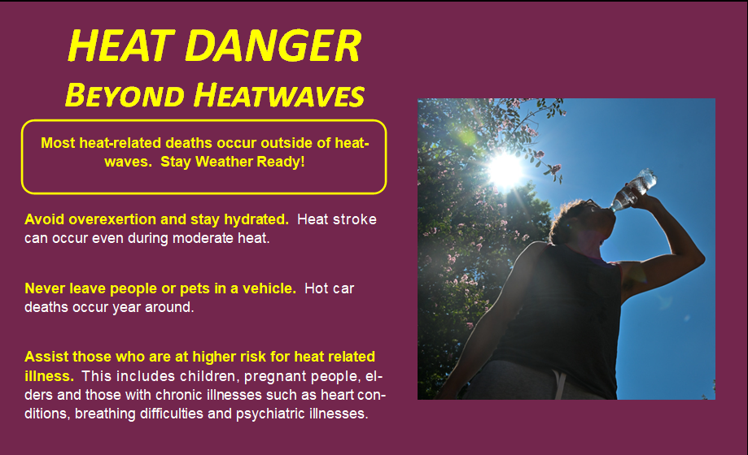
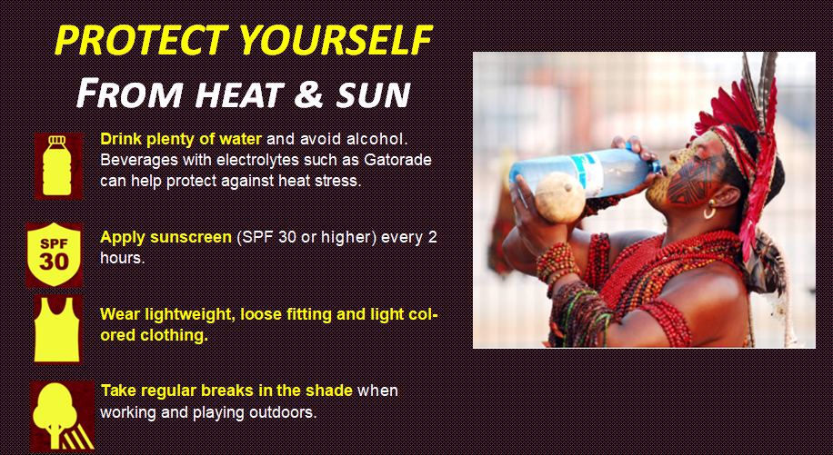

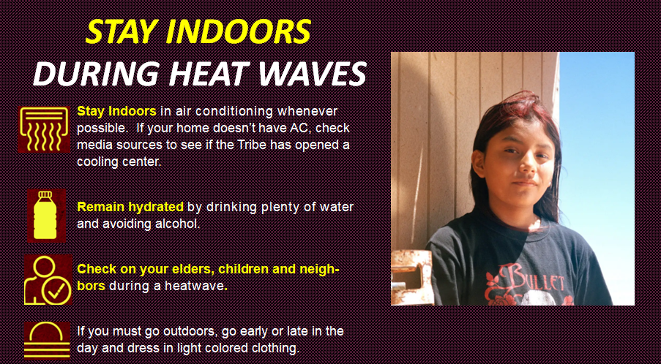

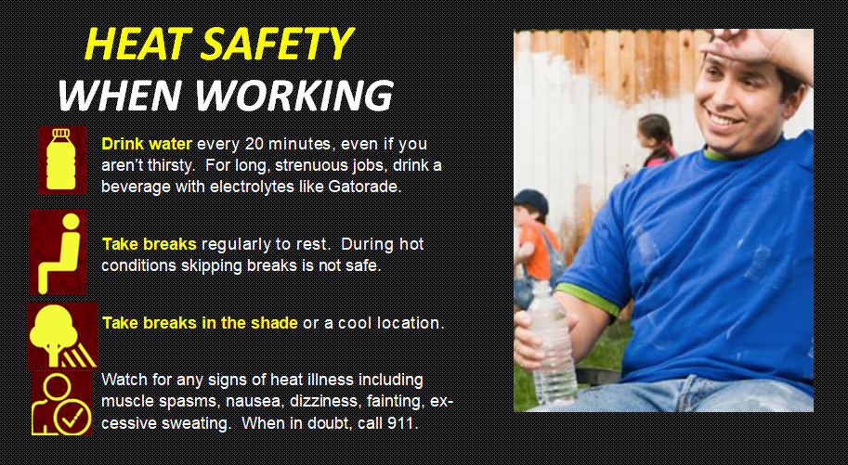

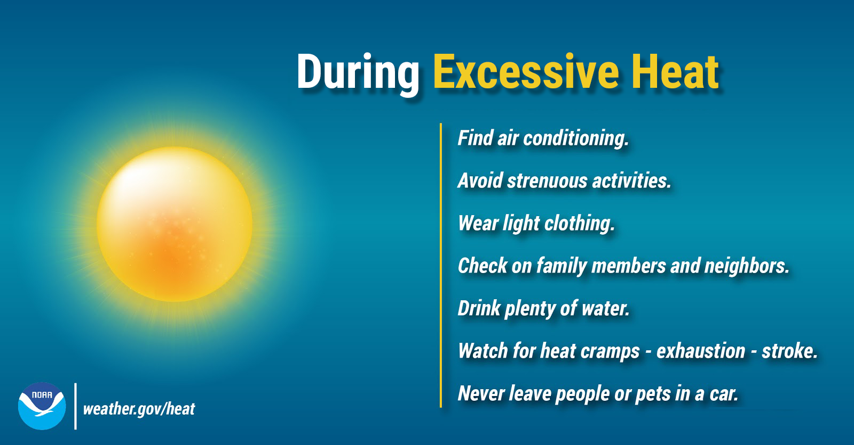

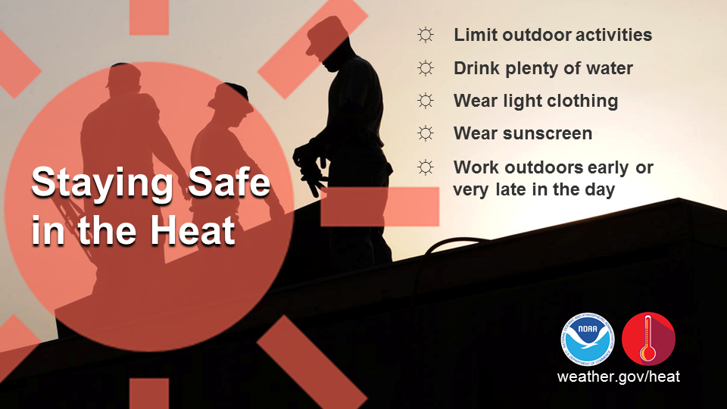

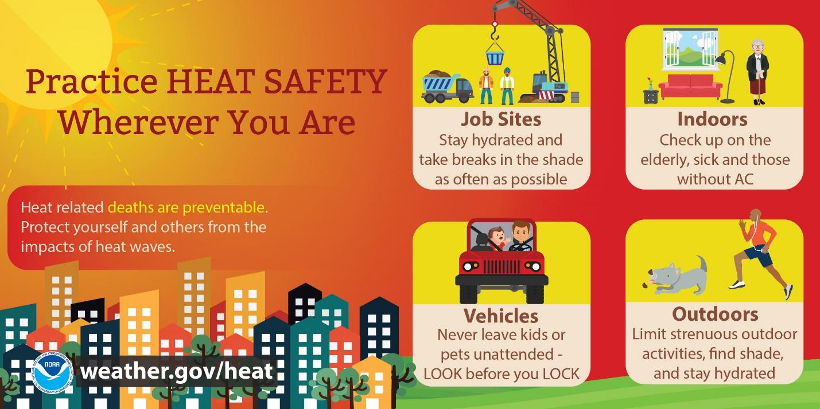
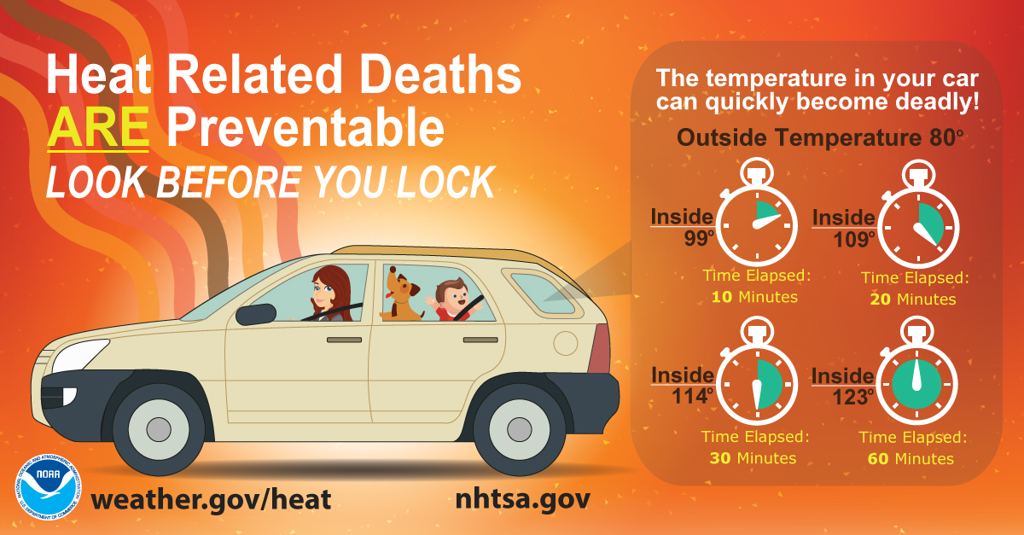

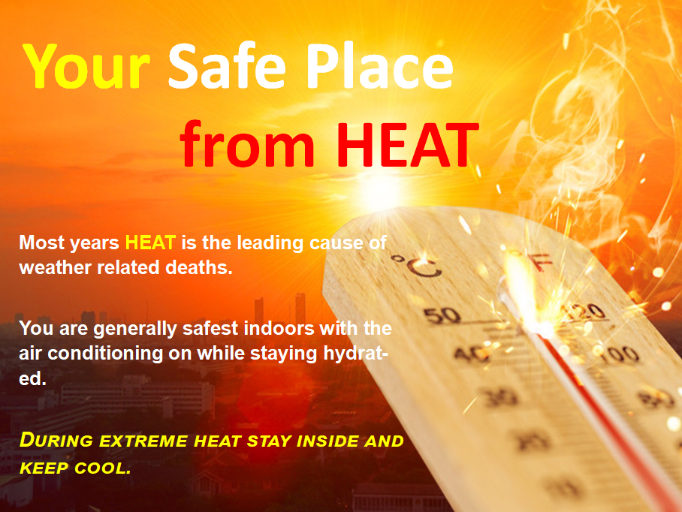
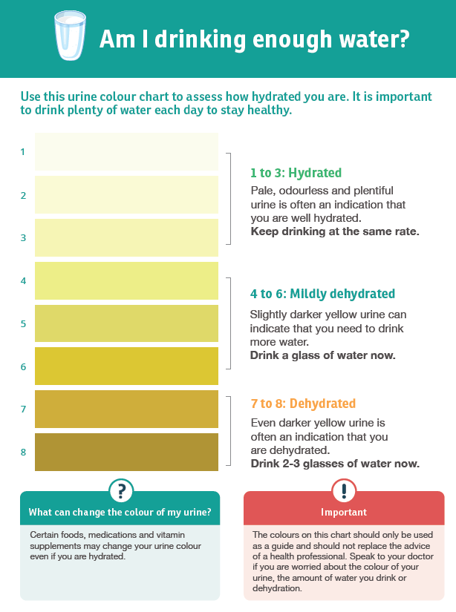
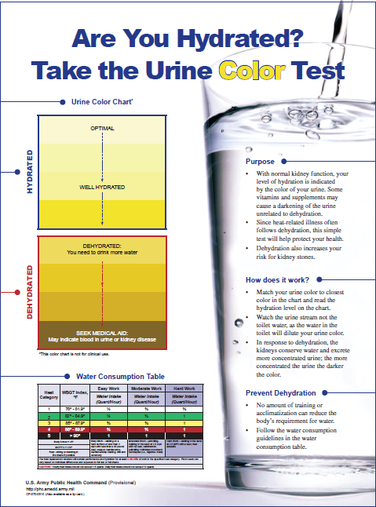

II. PHASE II HEAT WATCH

The <TRIBE NAME> response will enter Phase II when credible predictions by the National Weather Service of extreme heat or power outages during warmer than normal weather conditions have been issued for the <TRIBAL NAME> reservation. In this phase the Tribe’s <OFFICE OF EMERGENCY SERVICES/INCIDENT COMMAND STRUCTURE/TRIBAL HEALTH DEPARTMENT> will prepare to initiate its response plan which among other activities will include issuing a health alert to the community. Communication in Phase II is centered on increasing community awareness of the risks of extreme heat conditions, particularly for vulnerable community members.

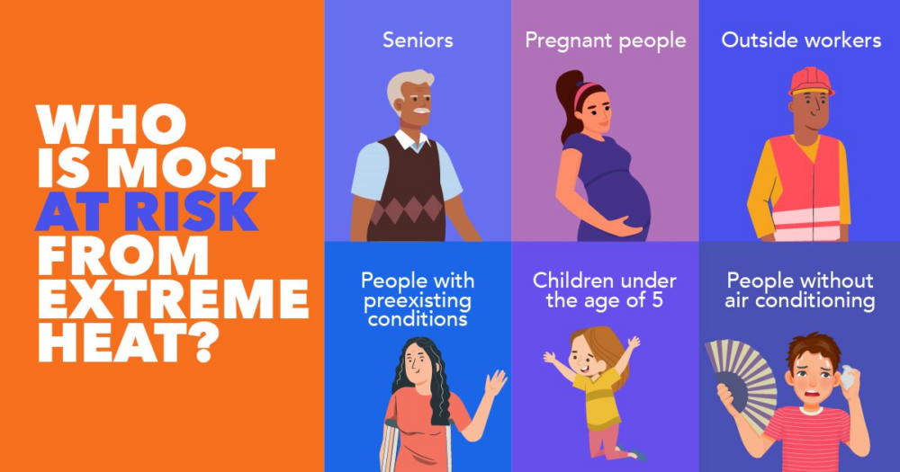
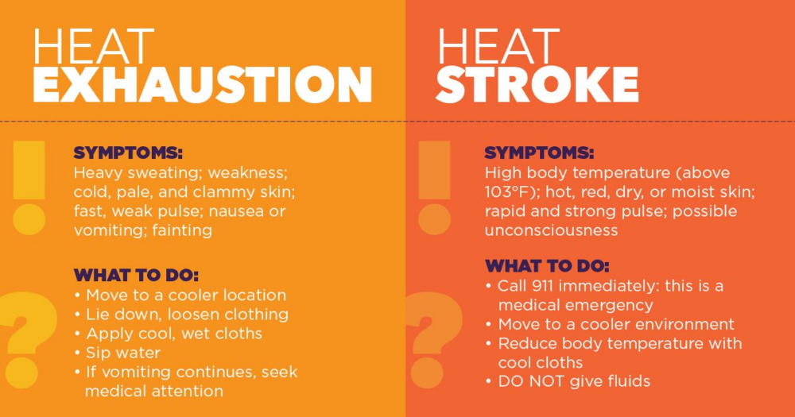

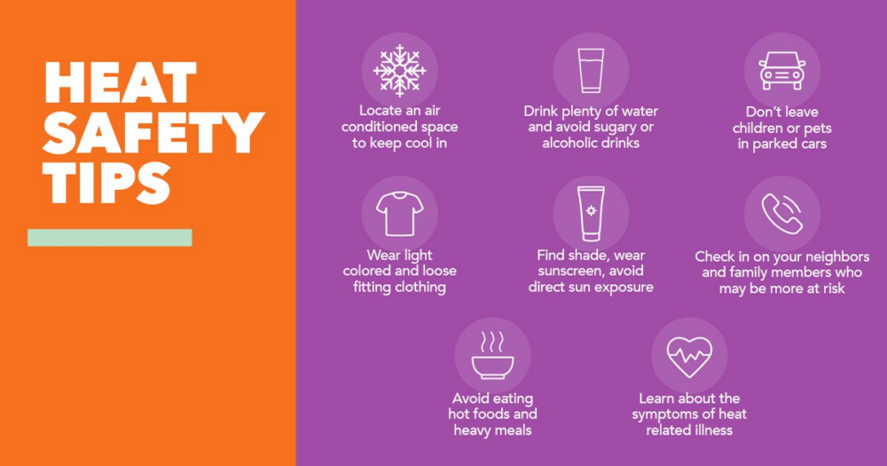
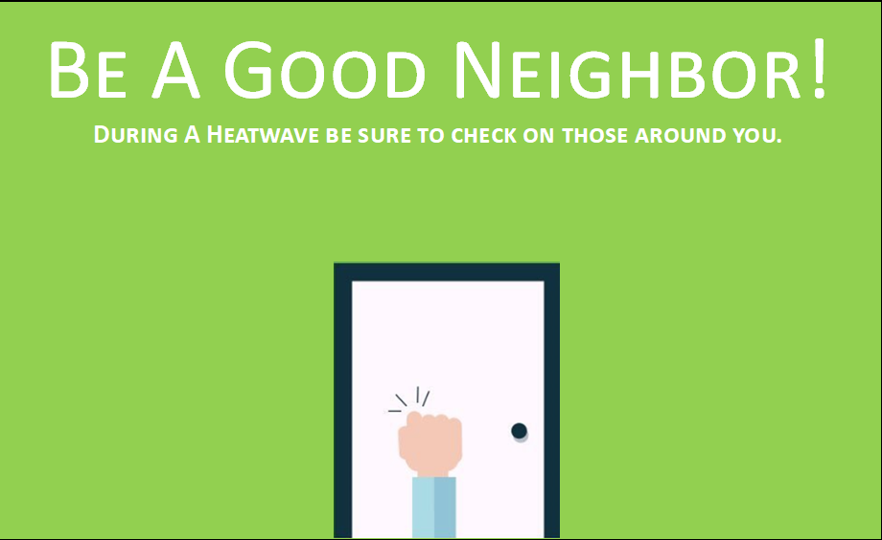

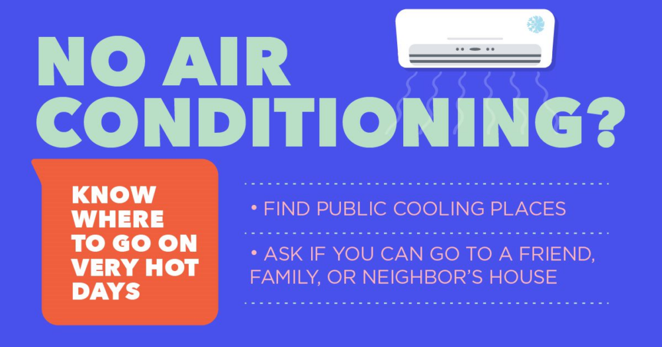
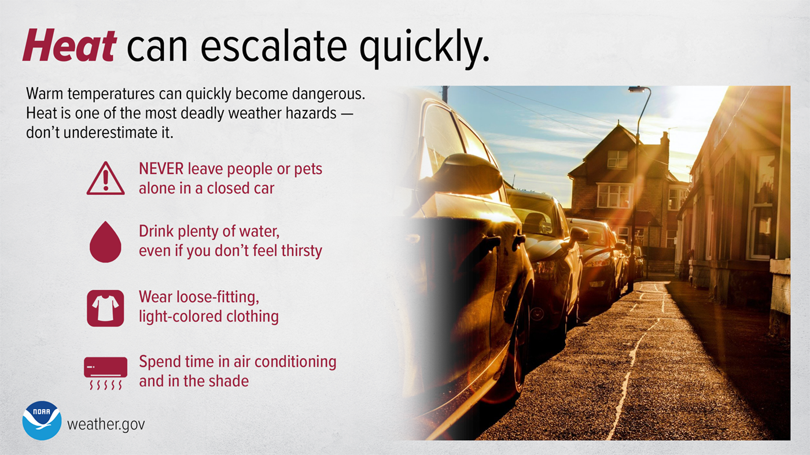

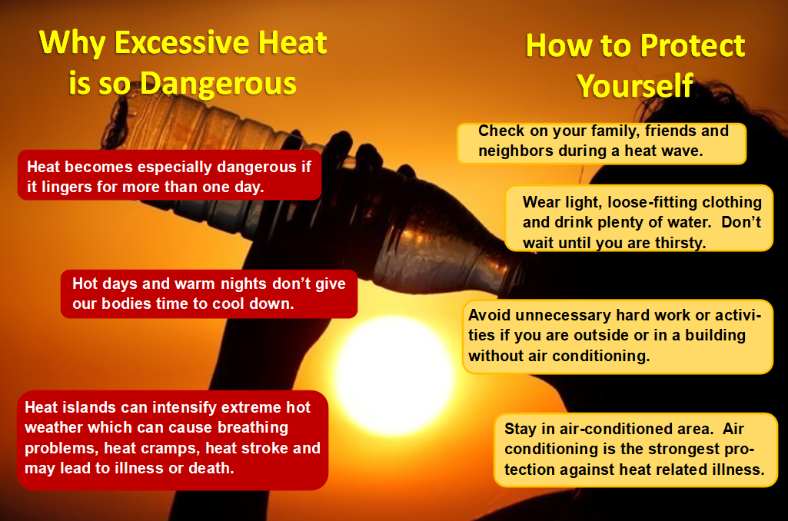
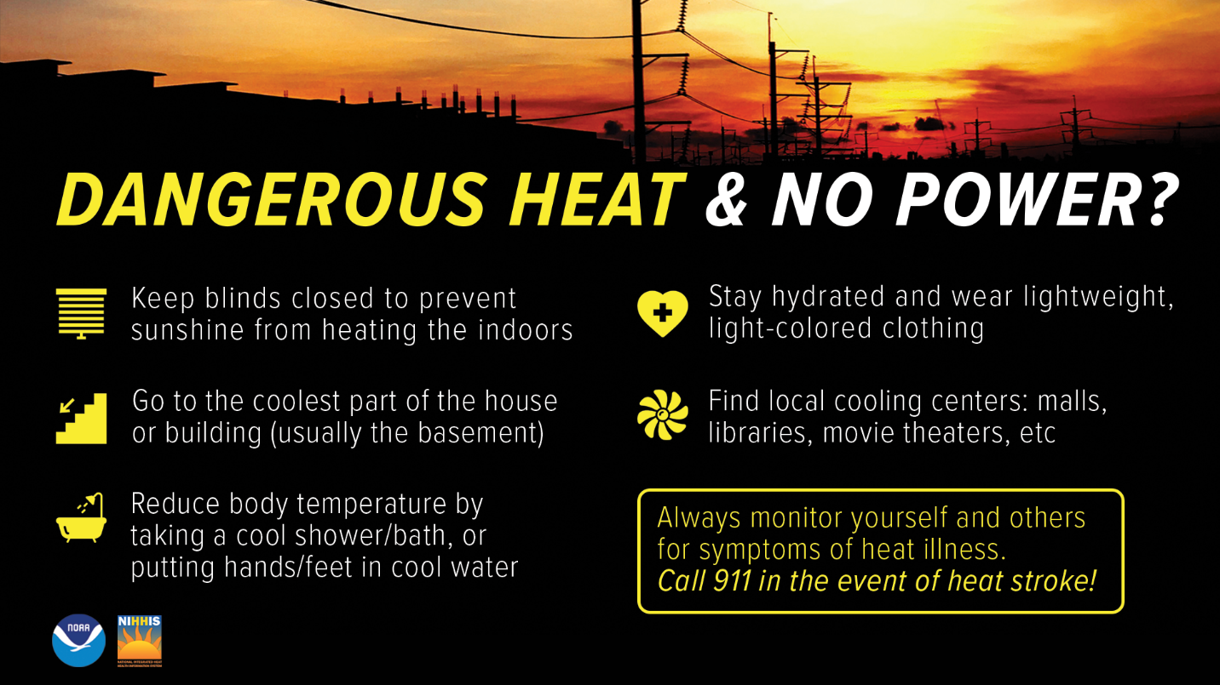

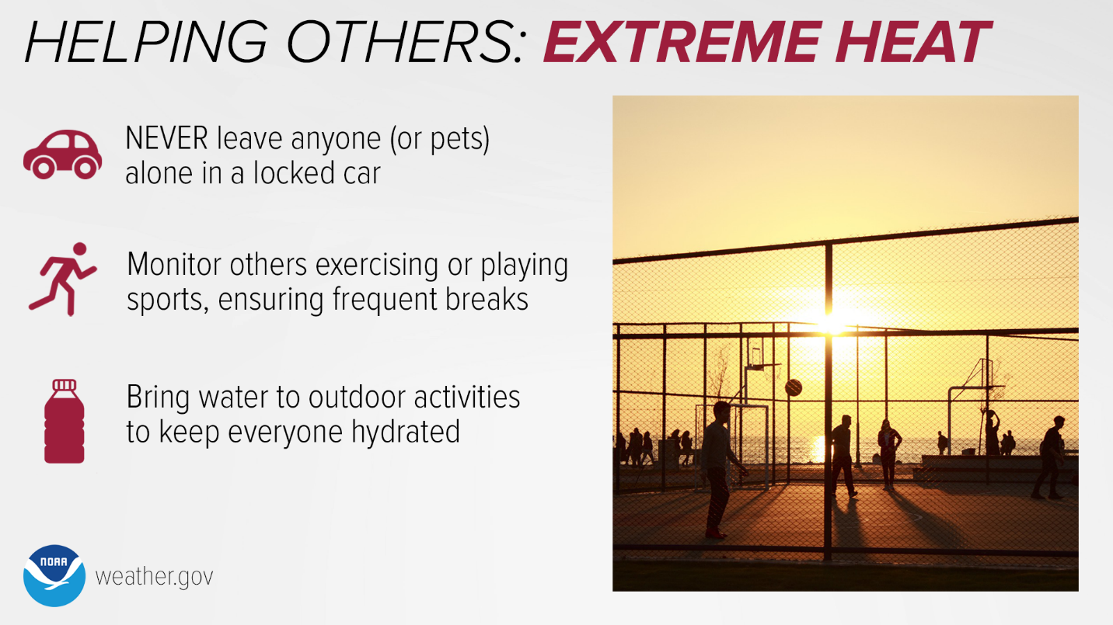
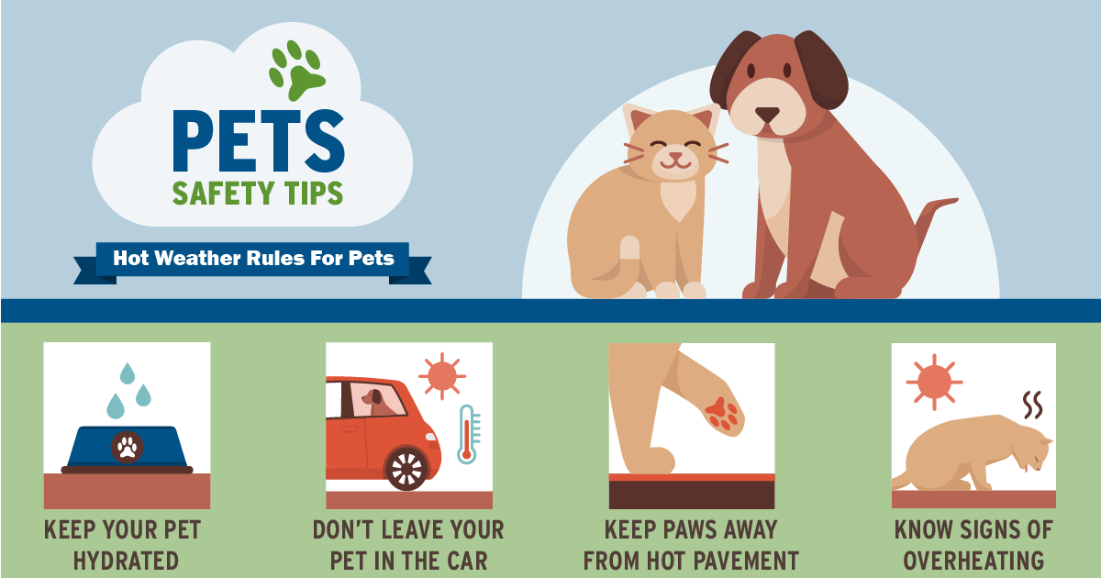
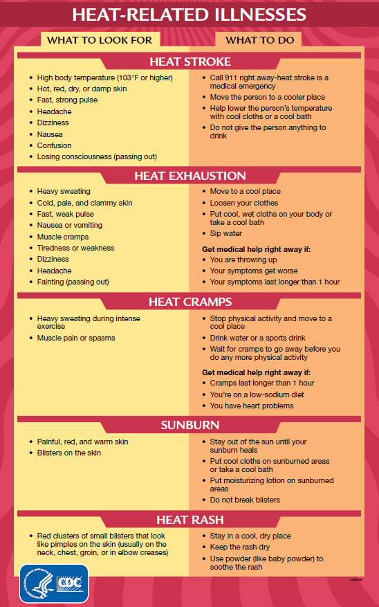

III. Phase II Heat Watch Messaging Verbiage

Below is language that can be used to communication public health and safety guidance to the <TRIBE NAME> community via <ID MEDIA OUTLETS THAT WILL BE USED TO COMMUNICATE WITH COMMUNITY> during Phase II of the response to a heat event.
Excessive Heat Outlook: Issued when excessive heat might happen in the next 3-7 days.
“A period of extreme heat is possible within the next 3 to 5 days. Stay informed and be prepared by following the preparedness information on <insert website link> in the event extreme heat occurs.”
Excessive Heat Watch: Issued when an excessive heat event is expected in the next 24 to 72 hours.
“A prolonged period of dangerous extreme heat is possible within about 48 hours. Drink plenty of water and stay in an air conditioned room. Never leave pets or children in vehicles. Heat stroke is a medical emergency—call 911 if anyone in your family or coworkers have symptoms of a body temperature 103°F or higher, hot, red, dry or damp skin, nausea, dizziness, confusion or loss of consciousness.”
Heat Advisory: Issued when the Heat Index will be equal to or greater than 100°F for at least 2 days and night temperatures will not drop below 75°F. Issued within 12 hours of onset of extremely dangerous heat conditions.
“A period of excessive heat is expected. The combination of hot temperatures and high humidity will create a situation in which heat related illnesses are possible. Make sure to drink plenty of water and stay indoors in an air conditioned room as much as possible. If working outdoors take plenty of breaks in the shade or an air conditioned space. Wear light, loose fitting clothing if you will be outside for any length of time. Heat stroke is a medical emergency—call 911 if anyone in your family or coworkers have symptoms of a body temperature 103°F or higher, hot, red, dry or damp skin, nausea, dizziness, confusion or loss of consciousness.”

IV. PHASE III HEAT WARNING

The response will enter Phase III when conditions pose a severe threat such as:
- the National Weather Service has issued an Extreme Heat Warning for the reservation
- the CDC/NWS Heat Risk is showing Magenta, Level 4, for the reservation, or
- the NWS has issued a Heat Advisory, Extreme Heat Watch or Warning and there are reports of an emergency or extended power outage on the reservation or abnormal animal mortality or human medical emergencies and/or deaths due to extreme heat on the reservation.
Graphics that can be distributed using <ID MEDIA OUTLETS USED TO COMMUNICATE WITH COMMUNITY> to communicate public health and safety information follow.
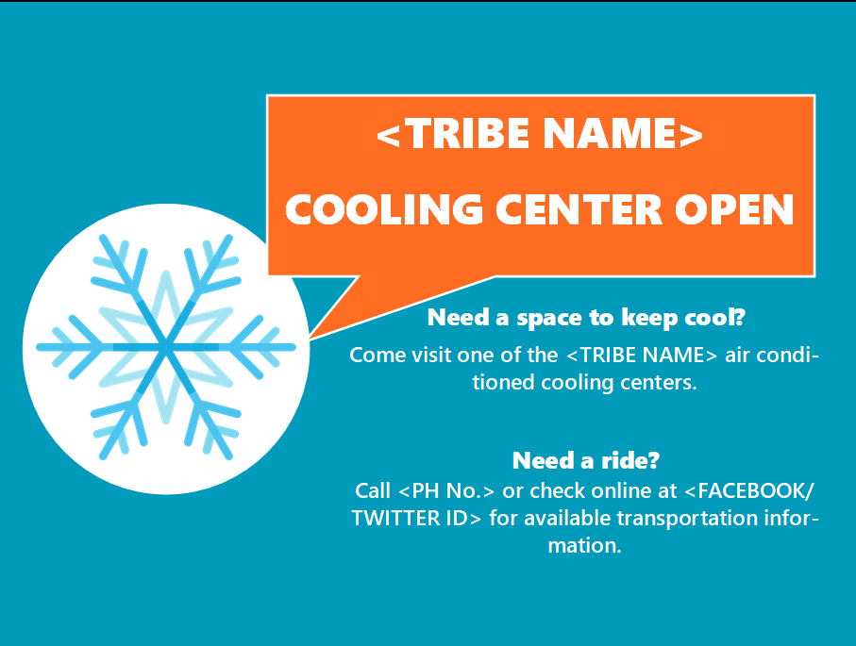

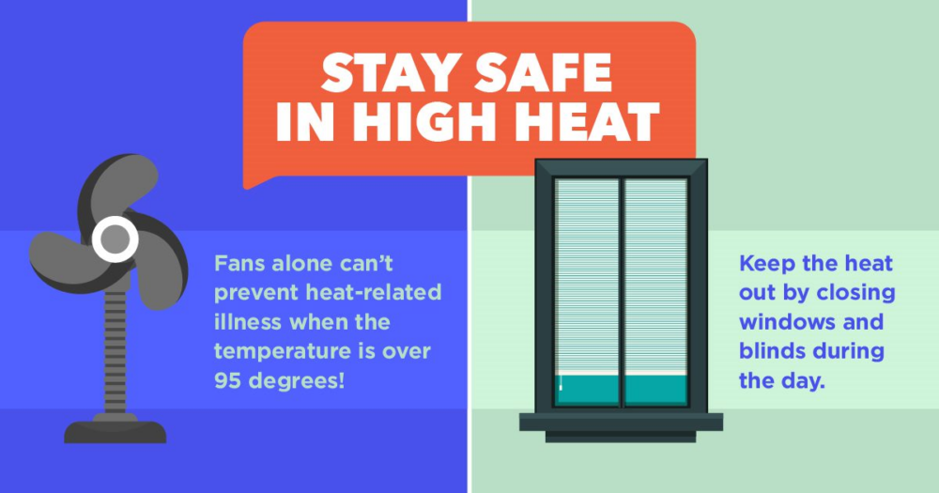

V. Phase III Heat Warning Messaging Verbiage

Below is language that can be used to communication public health and safety guidance to the <TRIBE NAME> community via <ID MEDIA OUTLETS THAT WILL BE USED TO COMMUNICATE WITH COMMUNITY> during Phase III of the response to a heat event.

Excessive Heat Warning: Heat indices will attain or exceed 105°F for at least 2 days and night temperatures will not drop below 75°F. Issued within 12 hours of the onset of extremely dangerous heat conditions.
“A prolonged period of dangerous excessive heat is expected within about 24 hours. The combination of hot temperatures and high humidity will create a dangerous situation in which heat related illnesses are likely. Reschedule strenuous outdoor activities for the early morning or evening when cooler temperatures prevail. Drink plenty of water and stay out of the sun and in an air conditioned place. Wear light weight, loose fitting clothing. Bring pets indoors into an air conditioned space and provide plenty of fresh water. Anyone overcome by heat should be moved to a cool and shaded location. Remember heat stroke is a medical emergency. Call 911 if anyone in your family or coworkers experience symptoms of a body temperature 103°F or higher, hot, red, dry or damp skin, nausea, dizziness, confusion or loss of consciousness.”

Sample Press Release

<Red print indicates insert relevant and local information>

<Place on official letterhead>

MEDIA RELEASE  Date: |  | CONTACTS:  <Name>, <Phone #>

Excessive Heat Emergencies
An excessive heat <heat category> for <area covered> runs through <date & time>. <Provide dew points and/or heat indices from NWS>. Excessive heat events are dangerous and conditions can be life-threatening.

Be sure that you and your family members stay cool and hydrated by drinking plenty of water. If you have air-conditioning, use it. If you do not, seek air-conditioned buildings during the heat of the day, such as public libraries and community centers, malls and movie theaters. <Other identified location> also provides an air-conditioned place where residents may go between the hours of <list hours of availability> to cool off and get out of the heat. <Insert address of place and if free transportation is available, list info.>

Quick Tips:
• Use air conditioning or spend time in air-conditioned locations
• Take a cool bath or shower
• Minimize direct exposure to the sun
• Limit your time outdoors as much as possible; take frequent breaks if you must be outside
• Stay hydrated – drink water and avoid alcohol
• Wear loose fitting, light-colored clothes
• Check on your neighbors, friends and family members – especially those who are older and /or with health issues
• Do not leave children or pets unattended in a vehicle, even with the windows rolled down, even for a few minutes

--More---
Anyone can be overcome by extreme heat, but some people are at higher risk than others. They include the elderly, the very young, and people with mental illness and chronic diseases. Signs of heat-related illnesses vary but can include the following: heavy sweating, paleness, muscle cramps, tiredness, weakness, dizziness, headache, nausea or vomiting, and fainting. Heat exhaustion can lead to heat stroke, which can cause death or permanent disability unless immediately treated. Symptoms of heat stroke include an extremely high body temperature (above 103°F); red, hot, and dry skin; rapid breathing; racing heart rate; headache; nausea; confusion; and unconsciousness. If heat stroke is suspected, call 911 immediately.

For additional information contact <insert local contact information>

Additional Social Media Messaging Resources:

- Los Angeles Regional Collaborative for Climate Action and Sustainability Extreme Heat Campaign Social Media Toolkit 2023

- University of Illinois Chicago Summer Heat Toolkit Social Media Messaging

- Ready.gov Extreme Heat Safety Social Media Toolkit

